The Photoelectric Effect

About

This is where light of a certain frequency can dislodge electrons from metals.

The frequency must be of a minimum frequency, or the electrons will merely heat up, and then release another photon.

The light causes the electron to gain enough energy to release it from the metal structure.

The energy, E given by the photon is found with the equation:

If more energy is provided than required to break the electron away, the remaining energy accelerates the electron to high speeds.

This also means that

Measuring
The photoelectric effect can be viewed by using a gold leaf electroscope.
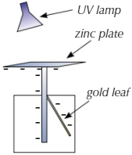
The zinc plate becomes negatively charged by touching a negative object to it, e.g. a statically charged piece of plastic.

When the gold leaf and the rod are both negative, they repel, causing the golf leaf to move away from the rod.

When the UV radiation hits the zinc plate, however, the UV rays cause the negative electrons to leave the metal. This makes the rod and the leaf less negative, so the gold leave slowly lowers until it is flat on the rod.

For zinc, the minimum frequency is UV light, so visible light has no effect, no matter the brightness.

